**Delta Chi Cruise**



**Royal Caribbean’s Allure of the Seas**

**Feb 14 - 22, 2026**

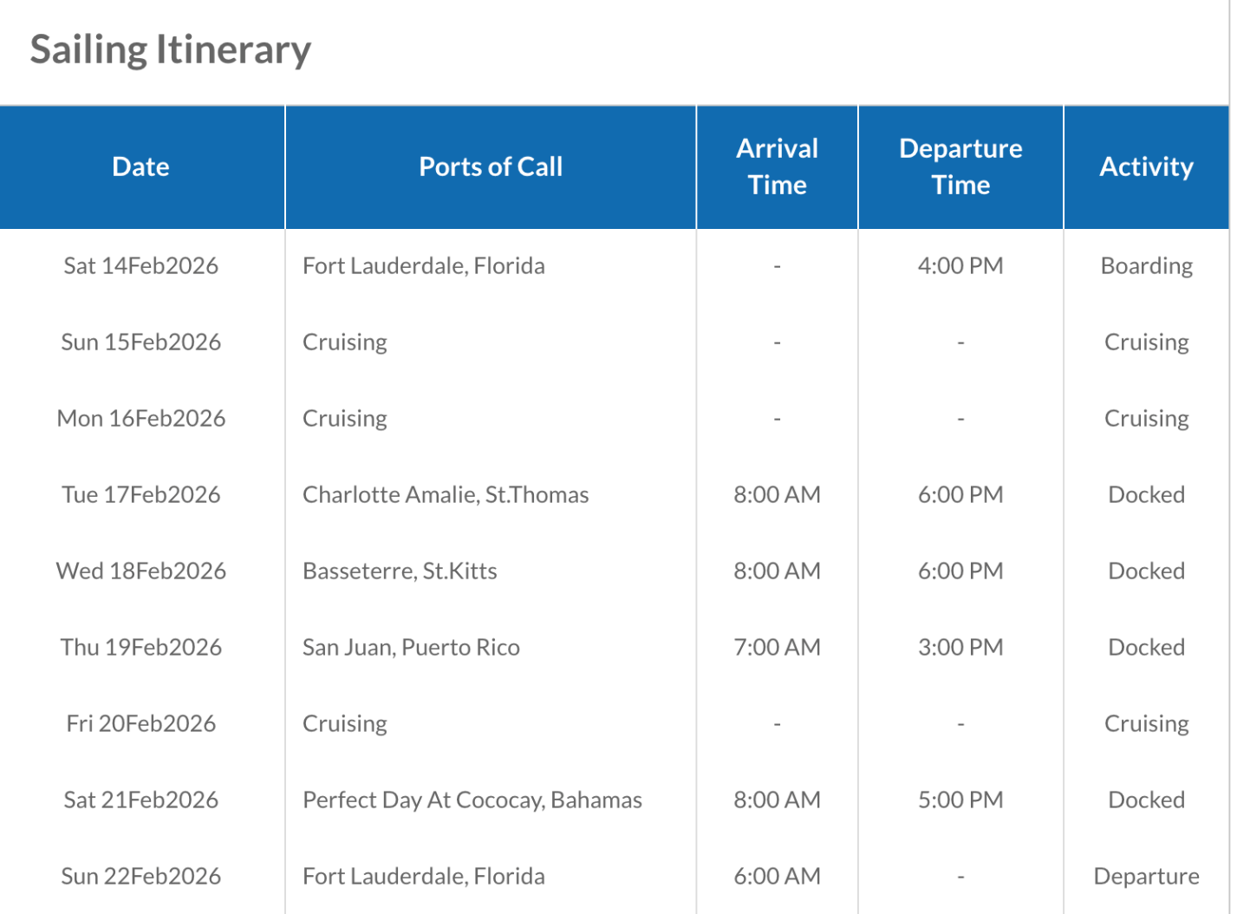

**RESERVATION REQUEST**

***Please complete all the information on this registration form. When complete, save this form and email it to*** [***ARNO@F1S.com***](mailto:ARNO@F1S.com)

A $500 deposit per cabin will be required before the booking is confirmed. Deposits are refundable until 90 days before the cruise. Cruise fares are per person, double occupancy, including taxes. Gratuities of $18.50 per person per day is an additional charge. Single cabins are 200%. Final payment is due November 1, 2025.

YES! PLEASE CONFIRM MY CABIN

(check only one choice)

2 D Deluxe Balcony Cabin $ 2067.81 per person

2 I Boardwalk Balcony Cabin $ 1271.81 per person

4 N Ocean View Cabin $ 1497.81per person

4 V Inside Cabin $ 1096.81 per person

PLEASE INDICATE ALL NAMES OCCUPYING THE SAME CABIN

(exactly as they appear on U.S. Passport)

**Guest One:**

FIRST/LAST NAME: Click or tap here to enter text.

STREET ADDRESS: Click or tap here to enter text.

CITY/STATE/ZIP: Click or tap here to enter text.

COUNTRY: Click or tap here to enter text.

E-MAIL ADDRESS: Click or tap here to enter text.

CELL PHONE           Click or tap here to enter text.

Date of birth:          Click or tap to enter a date.

Crown & Anchor #: (Optional) Click to enter Royal Caribbean Member number

**Guest Two:**

FIRST/LAST NAME: Click or tap here to enter text.

STREET ADDRESS: Click or tap here to enter text.

CITY/STATE/ZIP: Click or tap here to enter text.

COUNTRY: Click or tap here to enter text.

E-MAIL ADDRESS: Click or tap here to enter text.

CELL PHONE           Click or tap here to enter text.

Date of birth:          Click or tap to enter a date.

Crown & Anchor #: (Optional) Click to enter Royal Caribbean Member number

**Comments/Special Requests:**

Click or tap here to enter text.

**SPECIAL NOTE:  We will contact you separately for your Credit Card information.**

**If you have a special request, questions or anything else you want to ask or tell me,  please feel free to contact me any time by phone or email.**

**ARNO**

**304.964.0568**

**ARNO@F1S.com**

